

Using Variables in Manifest
DevOps Certification Training

support@intellipaat.com
+91-7022374614
US: 1-800-216-8930(Toll Free)

USING VARIABLES IN MANIFESTS
Steps for Puppet Master

Step 1: Change the directory to /etc/puppet/code/environments/production/manifests
$ cd /etc/puppet/code/environments/production/manifests
$ sudo nano site.pp

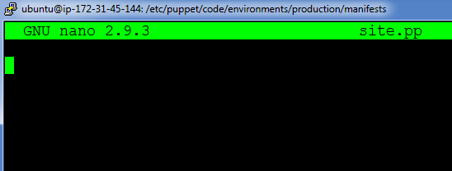

Step 2: Enter the following text:
node default{
$text= "hello world"
file{'/tmp/hello.txt':
content=> $text,
mode=> '0644',
}
}

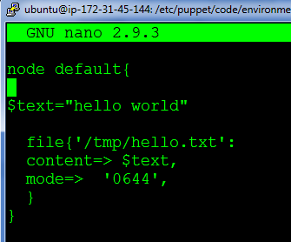

On Puppet Agent
Step 1: Execute the following command:
$ sudo puppet agent --test

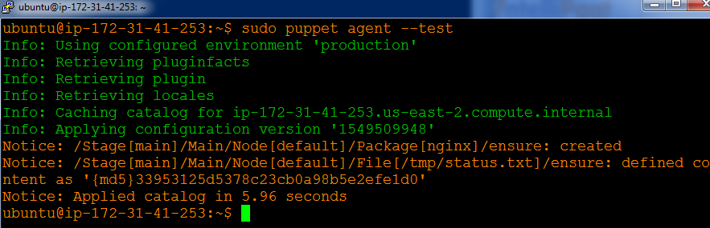

Step 2: Verify the installation and file by going to the browser, with agent’s ip address. Also check /tmp/hello.txt

